WEEK NUMBER: | 8
STUDENT NAME: | Anas Al Azad
STUDENT ID: | 105694136

WEEK # | 8
Dates covered: | 28 September -3 October 2026
Lab tasks | What I did | TIME SPENT | Learning & Problems
Theory – sequences & memory  Lab 8 sheet sections 1–2 | - Read how an RNN keeps a hidden state, why early info fades (vanishing gradient), how LSTM/GRU add gates + a cell state, and how attention links any two steps directly but needs positional encoding and costs O(T²).  - Understood the test task: sequences of T random digits, label = the first digit, so accuracy only measures memory (chance = 0.10). | 1 h | Learning:  - Hidden state = the RNN's memory, overwritten every step.  - Gates = learned switches for what to write / keep / forget.  - Attention is parallel and has no distance problem, but doesn't know order by itself.  Problems:  - None really for this one.
Part 1 – vanishing gradients  Lab8_RNN_LSTM_Attention.ipynb | - Ran the setup (3 sequences of 10 digits + labels ) and the gradient cell: fed a 50-step random sequence through each layer and measured the gradient at every input step.  - Gradient at the last step / first step: RNN 1.5e+13, LSTM 7.8e+10, GRU 2.8e+10 (Fig 8.1) – same as the sheet's typical result. | 0.5 h | Learning:  - The gradient shrinks exponentially going back in time – a straight line on a log plot.  - Gates help (LSTM/GRU shrink ~100× less) but don't fix it.  Problems:  - None really for this one.
Part 2 – RNN vs LSTM vs GRU  3 models × 4 lengths × 3 seeds | - Trained all 36 models (15 epochs each) – took 212 s on CPU (sheet said ~5 min).  - Mean accuracy for T = 5 / 10 / 20 / 60: RNN 1.00 / 0.66 / 0.10 / 0.10, LSTM 1.00 / 0.96 / 0.47 / 0.09, GRU 1.00 / 1.00 / 0.10 / 0.09 (Fig 8.3).  - Experiment 32 → 128 units at T = 20: RNN 0.77, LSTM 0.59, GRU 1.00 (sheet: 0.85 / 0.59 / 1.00). | 1.5 h | Learning:  - All three are perfect at T = 5; the plain RNN breaks first, the gated ones hold on longer, but by T = 60 everything is at chance.  - A bigger hidden state helped a lot at T = 20 (GRU 0.10 → 1.00).  Problems:  - Same settings, different seeds = very different results (RNN at T = 10: 0.79 / 1.00 / 0.19; LSTM at T = 20: 0.32 / 0.18 / 0.90) – had to look at all 3 runs, not just the mean.  - My RNN-128 result (0.77) is a bit lower than the sheet's 0.85 – probably a different CPU/PyTorch version; everything else matched exactly.
Part 3 – self-attention  + attention plot + ablation | - Self-attention with positional encoding: 1.00 / 1.00 / 1.00 for T = 10 / 20 / 60 – even T = 60 is easy because step 1 is only one hop from the last step.  - Attention plot at T = 20: the last position puts 0.95 (head 0) and 0.80 (head 1) of its weight on position 0 – it looks straight at the first digit (Fig 8.2).  - Ablation without positional encoding: 0.26 (T = 10) and 0.18 (T = 30).  - Worked out why: without order, the best possible guess is the most common digit in the sequence – I simulated that = 0.27 / 0.20, almost exactly what the model got. | 1.5 h | Learning:  - Attention without positions = a bag of digits (permutation-invariant).  - Positional encoding (sin/cos) gives every step a unique tag – that's what Transformers/LLMs rely on.  Problems:  - The sheet doesn't say why the ablation lands at 0.26 instead of chance (0.10) – the model can still count the digits, it just can't tell which one came first (I checked this with a simulation, see above).
Deliverable + extra  Lab8_Summary.pdf, extra experiment | - Wrote the one-page summary: results table (Parts 2 + 3), gradient plot, attention plot and my answers to the 3 checkpoint questions (make_summary.py builds it from the notebook's results.json, so it updates if I re-run).  - Extra: 40 epochs instead of 15 at T = 20 → LSTM 0.47 → 0.93, GRU 0.10 → 0.96, RNN 0.55 (one seed still stuck at 0.10). | 1.5 h | Learning:  - At T = 20 it's partly a training problem: the gated models CAN learn the dependency, they just need many more updates because the signal from step 1 is so weak.  Problems:  - Fitting everything on ONE page – had to put the two plots side by side and keep each answer to 3 sentences.
TOTAL TIME THIS WEEK |  | 6 h | + ~30 min screenshots & hand-in

Screenshots:
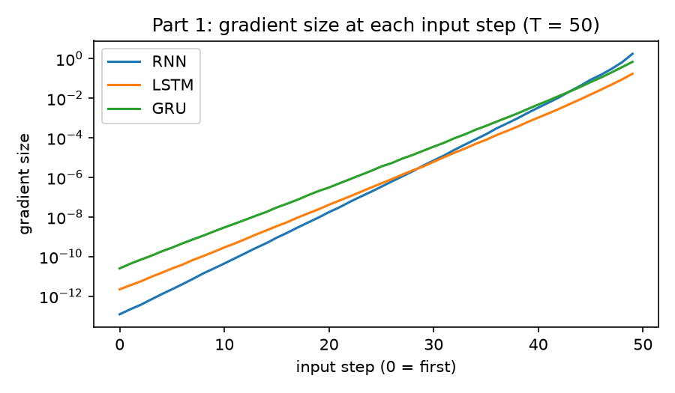
Figure 8.1 – Part 1 – gradient size at each of the 50 input steps (log scale)
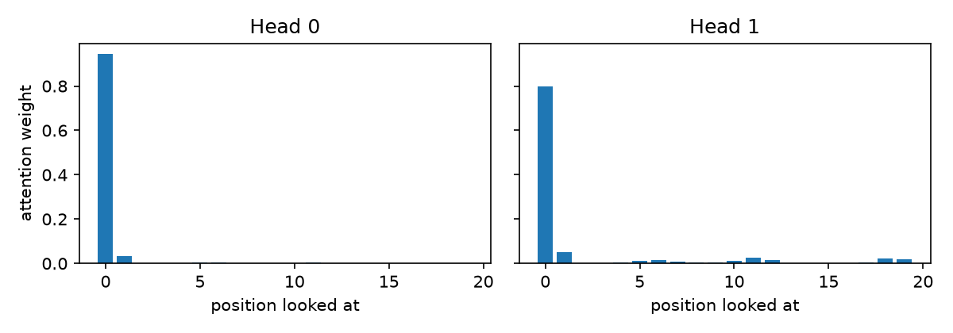
Figure 8.2 – Part 3 – where the last position looks at T = 20 (averaged over 200 sequences)
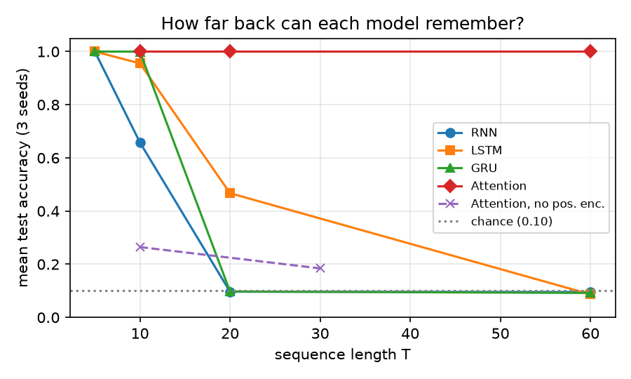
Figure 8.3 – mean test accuracy vs sequence length for every model (chance = 0.10)
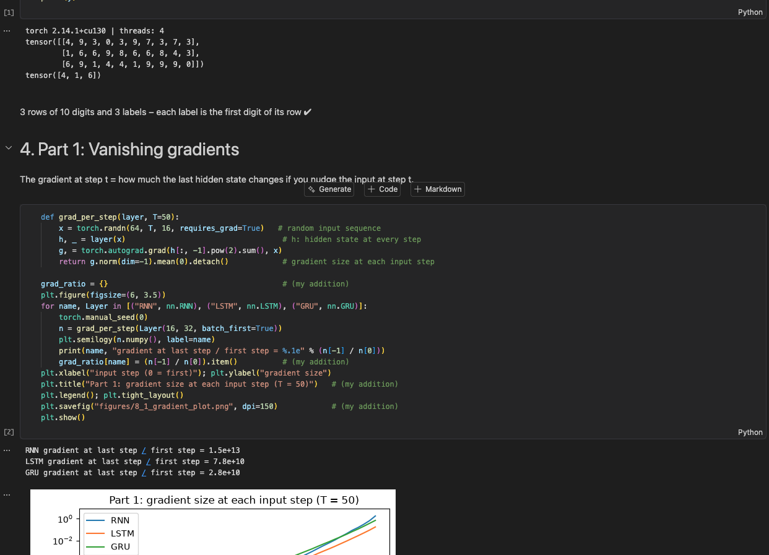Screenshot 8.1 – Notebook – setup + Part 1
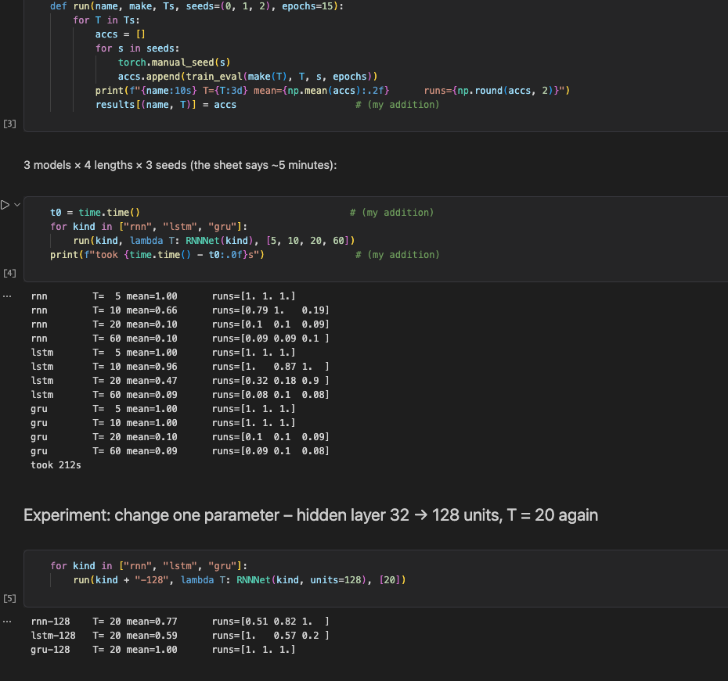Screenshot 8.2 – Notebook – Part 2 results
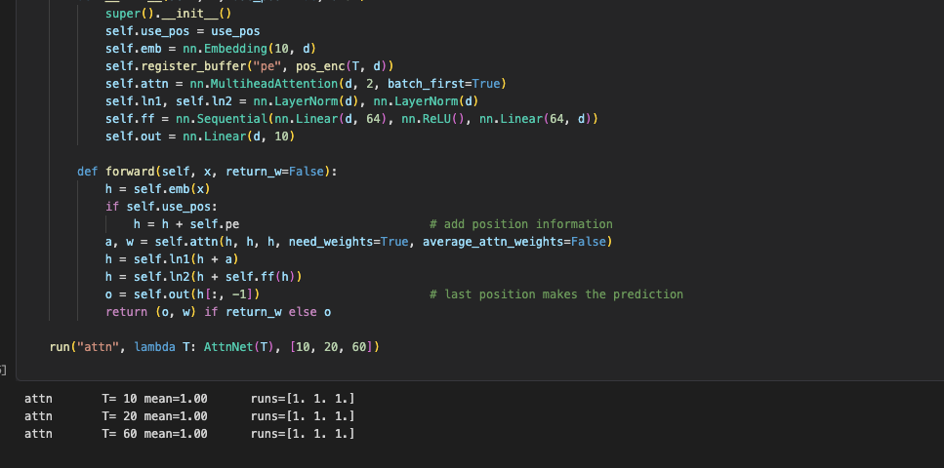Screenshot 8.3 – Notebook – Part 3 attention
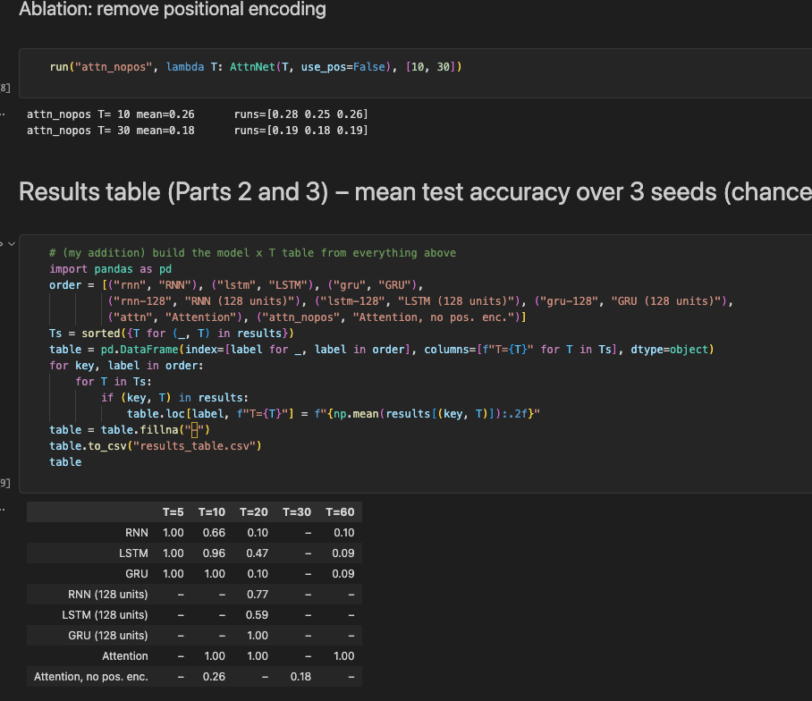Screenshot 8.4 – Notebook – ablation + results table
My one page summary:
Results (Parts 2 and 3) – mean test accuracy over 3 seeds; task = recall the first of T random digits; chance = 0.10
Model | T = 5 | T = 10 | T = 20 | T = 30 | T = 60
RNN | 1.00 | 0.66 | 0.10 | – | 0.10
LSTM | 1.00 | 0.96 | 0.47 | – | 0.09
GRU | 1.00 | 1.00 | 0.10 | – | 0.09
RNN, 128 units | – | – | 0.77 | – | –
LSTM, 128 units | – | – | 0.59 | – | –
GRU, 128 units | – | – | 1.00 | – | –
Self-attention | – | 1.00 | 1.00 | – | 1.00
Attention, no pos. enc. | – | 0.26 | – | 0.18 | –
Experiment (32 → 128 hidden units, T = 20) and the ablation (no positional encoding) are the extra rows. Green = ≥ 0.90, red = ≤ 0.20 (about chance).
Gradient plot (Part 1) and attention plot (Part 3)
Left: gradient size at each of 50 input steps (log scale) – last/first ratio RNN 1.5×10¹³, LSTM 7.8×10¹⁰, GRU 2.8×10¹⁰. Right: attention of the last position at T = 20, averaged over 200 sequences – weight on position 0: head 0 = 0.95, head 1 = 0.80.
Checkpoint questions
1. In Part 1, which input step has the smallest gradient? What does this mean for learning the first digit?
Step 0 the very first input has the smallest gradient for all three layers: the gradient at the last step is about 1.5×10¹³ times bigger for the RNN, 7.8×10¹⁰ for the LSTM and 2.8×10¹⁰ for the GRU. But the first digit is exactly what the label is, so the weights get almost no training signal about how to store it. That's why the plain RNN drops to chance (0.10) from T = 20, while the gated LSTM/GRU hold on a bit longer (fine at T = 10).
2. In Part 2, runs with the same settings give different accuracy. What does this tell you about training RNNs on long sequences?
Only the seed changes (initial weights + data order), yet the results jump around a lot: the RNN at T = 10 got 0.79 / 1.00 / 0.19 and the LSTM at T = 20 got 0.32 / 0.18 / 0.90. Because the gradient from the early steps is so tiny, whether a run ever finds the link between step 1 and the label is basically luck. So training RNNs on long sequences is unstable you need several seeds and should look at the spread, not just one number.
3. In Part 3, accuracy drops when you remove positional encoding. Why?
Self-attention on its own doesn't know about order it compares steps by content only, so without positional encoding the sequence is just a bag of digits and the model can't tell which one came first. The best it can do is guess the most common digit, which I calculated gives ≈0.27 for T = 10 and ≈0.20 for T = 30 basically the 0.26 and 0.18 I got. With positional encoding every step gets its own sin/cos tag, so the last position looks straight at position 0 (weights 0.95 / 0.80) and gets 1.00.

